How to configure so that Intellij IDEA tool auto wrap JAVA source code in editor ?

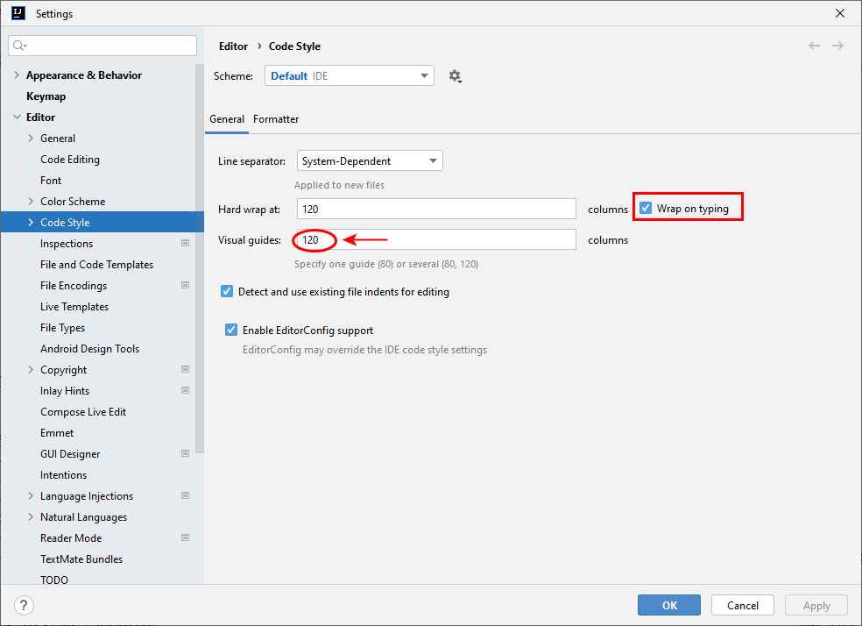

Intellij IDEA has built-in features to configure automatic wrapping of Java source code in the editor. Here are two ways to achieve this:

1. Using Code Style Settings:

* Open Settings (Ctrl+Alt+S on Windows and Linux, ⌘+, on macOS)
* Navigate to Editor > Code Style > Java
* Select the Wrapping and Braces tab
* Under Right margin, ensure the Ensure right margin is not exceeded checkbox is selected
* Choose your desired Wrap when typing reaches option and margin value
* Click Apply and OK

2. Using Code Formatting:

* Select the Java code you want to wrap
* Right-click and choose Reformat Code (Ctrl+Alt+L on Windows and Linux, ⌘+Alt+L on macOS)
* This will format the code based on your current code style settings, including wrapping lines at the specified right margin

Additional options:

* To configure different wrapping settings for different code blocks (e.g., comments vs. code), you can use Code Snippets and adjust their wrapping settings.
* You can also utilize the Surround with feature (Ctrl+Alt+T) to quickly wrap specific sections of code with desired structures like try-catch blocks or for loops.

Here are some helpful resources:

* Intellij IDEA Documentation - Reformat code: <https://www.jetbrains.com/help/idea/reformat-and-rearrange-code.html>
* Intellij IDEA Documentation - Surround code fragments: <https://www.jetbrains.com/help/idea/surrounding-blocks-of-code-with-language-constructs.html>

Remember that the wrapping settings might vary slightly depending on your specific Intellij IDEA version. If you encounter any difficulties or have further questions, feel free to consult the official Intellij IDEA documentation or online forums for additional assistance.